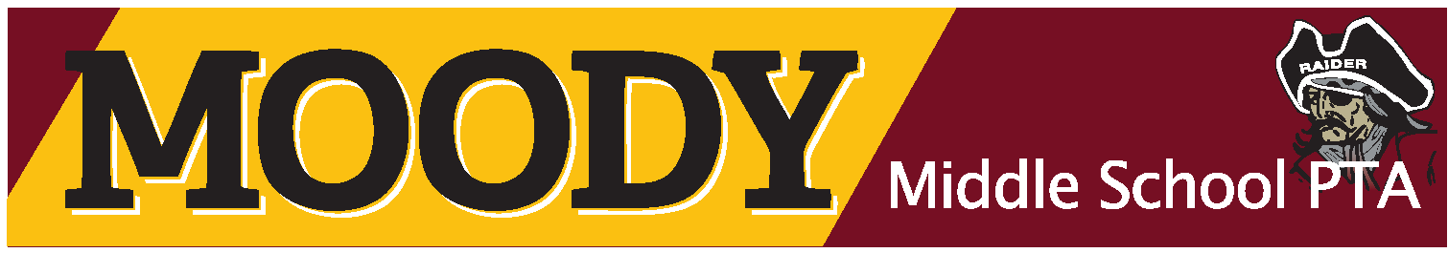
7800 WOODMAN ROAD I HENRICO, VA I 23228 I 804.261.5015 PH I 804.261.5024 FX

Dear Moody Supporter:
George H. Moody Middle School has been a part of the community since 1972. We have provided the youth of our community with an outstanding opportunity to learn from some of the best teachers in the area. Our hope is that our students continue to grow as individuals long after they leave Moody Middle School and become citizens of this community that we all can be proud of.
Our PTA board, teachers, administrative staff, and students donate countless hours each year in an effort to make Moody Middle School one of the best schools in Henrico County. In order to continue to maintain the high quality programs that our students have come to expect, we look to businesses and individuals within our community for the financial support necessary to ensure our extracurricular programs, athletics programs, and clubs have the best equipment possibly available to them.
We will holding our Third Annual Golf Tournament on Saturday, May 20, 2017 at Belmont Golf Course. We are using the funds raised from this great event to benefit our Athletic programs.
Here are the ways that you can participate:
Hole Sponsorship: $100.00 - If you choose to become a corporate plus sponsor your company name will be listed on the hole. Your advertising will be seen at our golf tournament, flyers, and featured in our online newsletter, and this is 100% tax deductible. (Tax ID # SE541148307F02142017)
If you choose to make a monetary donation in lieu of a Hole Sponsorship, this would also be welcomed and greatly appreciated by our school community. An in-kind donation are also accepted.
If you have further questions or need additional information please contact Ms. Christina Willis at 804-370-2627or via email at: Christina.Wilis@tscg.com.
Your time and consideration of this request is greatly appreciated. I would personally like to thank you in advance for your participation and support of the youth of our community and our school.
Sincerely,
Moody Middle School PTA Athletic Booster Committee

Sponsorship Information:

Date: __________________________

Name:________________________________________________________________________

Address:______________________________________________________________________

Email: ________________________________________________________________________

Phone:________________________________ Cell Phone: ____________________________

Contact:_______________________________________________________________________

Select option for sponsorship:

__________________ Hole Sponsorship Plus $100.00

__________________ We cannot attend or sponsor a hole, here is our donation of _________

Please make checks payable to Moody Middle School PTA and return this form to Lori Tuskey at Moody Middle School 7800 Woodman Road Henrico, VA 23228.
Our deadline for sponsorship for the 2016 season is April 30, 2017. This will allow time for our school to have signs prepared for our tournament on Saturday, May 20, 2017.
Thank you again for your consideration of this request. We hope to see you there!
Sincerely,
Moody Middle School PTA Athletic Booster Committee

