PTA Membership form & Tax Receipt  Welcome to the 2016-2017 School Year! We invite all parents/guardians to become PTA members. Please turn this in at OPEN HOUSE or send it to your child’s home room teacher by 10/14. Visit www.gomoodypta.com for the details.  Make checks payable to MMS PTA. | Please PRINT LEGIBLY for school directory information.  2
MEMBERSHIP: RAIDER FUND DONOR | MEMBERSHIP: GENERAL |  |  | TOTAL
The Raider Fund is Moody PTA’s primary fund raiser. Your contribution is 100% tax- deductible and greatly appreciated. If your employer offers a matching gift program, please enclose the appropriate form and we will take care of the rest.  $100 + per family includes:  - Gold Donor status in Directory  - 2 PTA Memberships  - 2 Raider Fund Donor Car Magnets  - 1 Moody Middle School Directory  $55 - $99 per family includes  - Silver Donor status in Directory  - 1 PTA Membership  - 1 Raider Fund Donor Car Magnet  - 1 Moody Middle School Directory  $1 - $54 per family includes  - Bronze Donor status in Directory  - 1 Moody Middle School Directory | (100% Tax Deductible)  PTA Membership  Please join the PTA. Stay informed and help build a strong unified voice on behalf of our children.  Thanks for your support and help in reaching our goal of 100% membership by having all adult family members join the PTA.  $7 for one membership  One membership is already included with  $55-$99 Raider Fund donation  $12 for two memberships  Two memberships are already included with  $100+ Raider Fund Donation |  |  | $
OTHER ITEM SUMMARY | COST
George H. Moody Directory  All PTA member families will receive a directory as part of their membership. | N/A |  |  | Do Not include my child’s info in the Directory
Convenience Fee  (Only available during Open House) | A $2.50 convenience fee facilitates credit card  payment. |  |  | $
FORM DUE BY October 14 | TOTAL (Payable to MMS PTA) |  |  | $

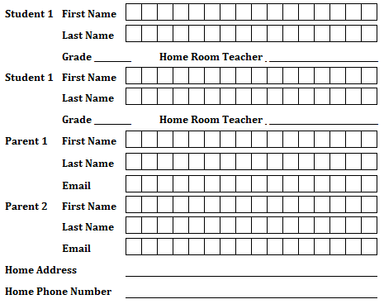
Check # _________________ Amount $_______________ PTA Board Member initials________ Magnet Given

